**Assignment No: 5**

**Text Identification Using OpenCV, Tesseract (OCR), and Deep Neural Network**

**Problem Statement:**

To implement a system that identifies and extracts text from images using OpenCV for image processing, Tesseract for Optical Character Recognition (OCR), and a deep neural network for further enhancement of text extraction.

**Objective:**

1. **To understand the basics of image processing using OpenCV.**
   * Explore different image processing techniques such as filtering, resizing, and edge detection.
   * Gain hands-on experience with manipulating image pixels for preprocessing.
2. **To learn how to use Tesseract for OCR.**
   * Understand the installation and configuration of Tesseract.
   * Familiarize yourself with different Tesseract modes and how they can be utilized for various text extraction tasks.
3. **To explore deep learning techniques for improving text recognition accuracy.**
   * Investigate how deep learning models can be trained on annotated datasets to improve OCR results.
   * Explore different architectures (like CNNs) that can be effective for image recognition tasks.

**S/W Packages and H/W Apparatus Used:**

* **Operating System:** Windows/Linux/MacOS
* **Kernel:** Python 3.x
* **Tools:** Jupyter Notebook, Anaconda, or Google Colab
* **Hardware:** CPU with minimum 4GB RAM; optional GPU for faster processing

**Libraries and Packages Used:**

* **OpenCV:** Library for computer vision and image processing tasks.
* **Tesseract:** An open-source OCR engine that converts images of text into machine-encoded text.
* **NumPy:** Library for numerical computations and array manipulations.
* **Matplotlib:** Library for visualizing data and images.
* **TensorFlow/Keras:** Frameworks for building and training deep learning models (if using a neural network).

**Theory:**

1. **OpenCV:**
   * A powerful library for performing various image processing operations, allowing users to read, write, and manipulate images with ease. Key functionalities include image filtering, transformations, and feature detection.
2. **Tesseract:**
   * A leading OCR tool that uses machine learning to identify text within images. Tesseract can be trained to recognize different languages and fonts, making it highly adaptable for various applications.
3. **Deep Learning:**
   * A subset of machine learning involving neural networks with multiple layers that can automatically learn representations from data. In text recognition, deep learning models can be trained on large datasets to improve accuracy significantly.
4. **Methodology:**
   * **Image Acquisition:**
     + Load images using OpenCV, allowing for different image formats and resolutions.
     + Ensure the dataset is diverse enough to train the model effectively.
   * **Preprocessing:**
     + Convert images to grayscale to simplify the data.
     + Apply thresholding to create binary images, which makes it easier for Tesseract to identify text.
     + Perform morphological operations like dilation and erosion to enhance text visibility and remove noise.
   * **Text Extraction:**
     + Use Tesseract to extract text from preprocessed images. Experiment with different Tesseract configurations to optimize results.
   * **Deep Learning Enhancement:**
     + Optionally, implement a deep learning model (like CNN) to refine the text recognition process. Train the model on labeled datasets, using techniques like data augmentation to improve performance.
   * **Evaluation:**
     + Measure the accuracy of text extraction using metrics such as precision, recall, and F1-score. Visualize results with charts to illustrate performance improvements.

**Advantages:**

* **Accurate text recognition from images:** Enables reliable extraction of information for various applications.
* **Ability to handle various fonts and layouts:** Tesseract can adapt to different styles, enhancing its versatility.

**Limitations:**

* **Performance may vary based on image quality and complexity:** Low-quality images may yield poor results, requiring robust preprocessing.
* **Requires proper preprocessing for optimal results:** Effective preprocessing is crucial for maximizing recognition accuracy.

**Applications:**

* **Document scanning:** Automating the digitization of printed materials for easier access and searchability.
* **License plate recognition:** Used in security systems and traffic monitoring to identify vehicle plates automatically.
* **Data extraction from images:** Extracting relevant information from forms, invoices, and other document types.

**Working/Algorithm:**

**Step 1: Import Necessary Libraries**

* Import necessary libraries: OpenCV, Tesseract, NumPy, Matplotlib, TensorFlow/Keras (if using a neural network).

**Step 2: Image Acquisition**

* Load the input images using OpenCV (cv2.imread()).

**Step 3: Preprocessing**

* Convert the image to grayscale (cv2.cvtColor(image, cv2.COLOR_BGR2GRAY)).
* Apply thresholding to create a binary image (cv2.threshold()).
* Perform morphological operations (e.g., erosion and dilation) to enhance text visibility (cv2.morphologyEx()).

**Step 4: Text Extraction**

* Use Tesseract to extract text from the preprocessed image (pytesseract.image_to_string()).

**Step 5: Deep Learning Enhancement (Optional):**

* Prepare the dataset for training a deep learning model (if using).
* Split the dataset into training and validation sets.
* Define a neural network architecture using TensorFlow/Keras.
* Compile the model with an optimizer and loss function.
* Train the model using the training data and validate using the validation set.

**Step 6: Evaluation**

* Measure the accuracy of text extraction using metrics such as character error rate (CER) or word error rate (WER).
* Visualize the results using Matplotlib.

**Step 7: Display Result:**

* Print or display the extracted text on the screen or save it to a file.

**Diagram:**

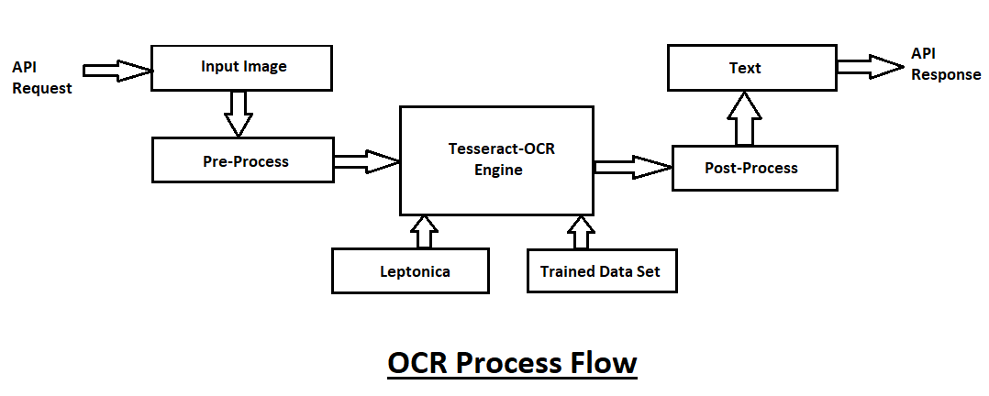

**Conclusion:**

The integration of OpenCV, Tesseract, and deep learning techniques provides a robust and versatile solution for text identification in images. This comprehensive approach facilitates accurate text extraction from a wide variety of formats and conditions, demonstrating its practical applicability in real-world scenarios such as document scanning, form processing, and data extraction from images.

While the system can achieve high accuracy under optimal conditions, performance can vary based on image quality, text clarity, and preprocessing effectiveness. Therefore, careful implementation and tuning of preprocessing techniques are crucial to maximize OCR performance.

Moreover, leveraging deep learning methods can significantly enhance the system's capabilities, especially in recognizing more complex text features and overcoming challenges posed by diverse fonts and layouts. Overall, this project highlights the importance of combining traditional image processing methods with advanced machine learning techniques to achieve superior results in text identification tasks.